进入官网

<https://www.jetbrains.com/help/webstorm/meet-webstorm.html>

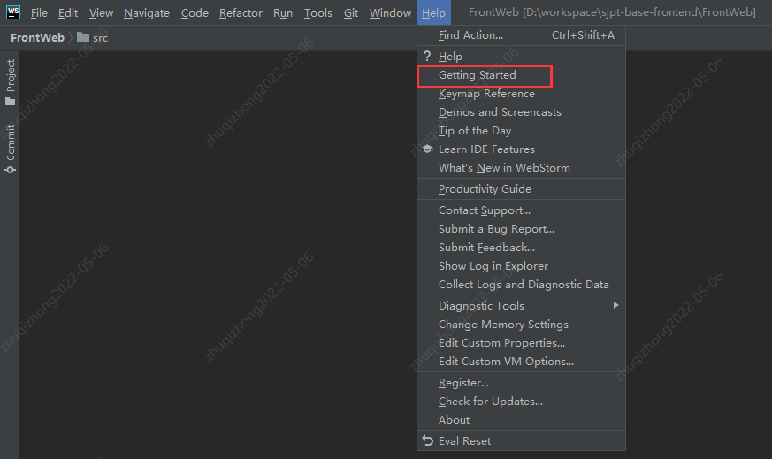

看的版本



You are viewing the documentation for an earlier version of WebStorm.

Install WebStorm

Last modified: 29 December 2021

WebStorm is a cross-platform IDE that provides consistent experience on the Windows, macOS, and Linux operating systems.

System requirements

| **Requirement** | **Minimum** | **Recommended** |
| --- | --- | --- |
| RAM | 2 GB of free RAM | 8 GB of total system RAM |
| CPU | Any modern CPU | Multi-core CPU. WebStorm supports multithreading for different operations and processes making it faster the more CPU cores it can use. |
| Disk space | 2.5 GB and another 1 GB for caches | SSD drive with at least 5 GB of free space |
| Monitor resolution | 1024x768 | 1920×1080 |
| Operating system | Officially released 64-bit versions of the following:  Microsoft Windows 8 or later  macOS 10.14 or later  Any Linux distribution that supports Gnome, KDE , or Unity DE.  Pre-release versions are not supported. | Latest 64-bit version of Windows, macOS, or Linux (for example, Debian, Ubuntu, or RHEL) |

You do not need to install Java to run WebStorm because JetBrains Runtime is bundled with the IDE (based on JRE 11).